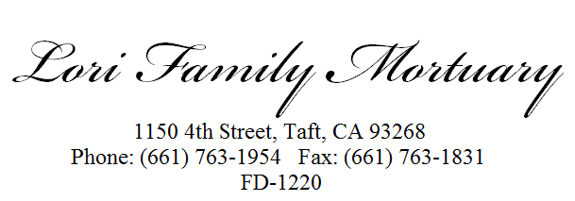

AUTHORIZATION FOR DISPOSITION WITH OR WITHOUT EMBALMING

TO: ____________________________________________________________(Funeral Establishment Name)

RE: ________________________________(Decedent) I, _________________________________________
do __do not __(check one) request embalming, which I understand is the addition to, or the replacement of, body fluids by chemical preservatives or the application of chemical preservatives for the temporary preservation of the body. I understand that embalming is not required by law.

I understand that for storage or embalming purposes the decedent may be transported to the following licensed funeral establishment:
Lori Family Mortuary, 1150 4th Street, Taft, CA 93268______________________________________________
(name and address of funeral establishment)
then returned for funeral services. I understand I may be charged an additional fee for transport of the decedent.

The undersigned hereby represents that he/she has the legal right to control disposition of the remains of the decedent.

Signed: __________________________, Relationship __________
Executed this ____day of ___________________, _____, at City ____________________, State ___.

To Be Completed by funeral establishment if Authorization to Embalm and Notification to Transport Is Obtained Orally (by Telephone):

The above statement of authorization and notification was read to __________________________________, Relationship __________, who did __did not __(check one) authorize embalming at the above named funeral establishment. City _______________, State ___, Phone (____________) Date and time authorization granted: ________________________

Signature of funeral establishment representative accepting authorization.

I declare under penalty of perjury that the foregoing is true and correct. Executed this ____day of ____________________, _____, at City _____________________, State ___.

(s) __________________________

