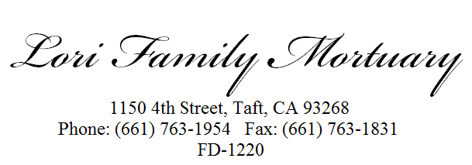

DECLARATION FOR DISPOSITION OF CREMATED REMAINS
I/ We hereby declare (my remains) or (the remains of)________________________________________in
Name of Person Arrangements are for
the possession of ______________________________________________________,will be cremated by
Name of Funeral Establishment and Telephone Number
____________________________________________________________ and shall be disposed of in the
Name of Crematory and Telephone Number
Following manner (note 1): ____________________________________________________________________________________
Manner, Location and Other Details of Disposition
____________________________________________________________________________________
____________________________________________________________________________________
____________________________________________________________________________________
Attach additional pages if necessary
Name of person(s) with the legal right to control disposition (note 2): ________________________________
____________________________________________________________________________________
_____________________________________________________________________________________

Signed _________________________________________________ Date ________________________
Person(s) with legal right to control disposition or Self, if prearranging
Signed _________________________________________________ Date ________________________
Person(s) with legal right to control disposition
Signed _________________________________________________ Date ________________________
Person(s) with legal right to control disposition
Signed _________________________________________________ Date ________________________
Person(s) with legal right to control disposition
Name of person(s) contracting for cremation services__________________________________________
____________________________________________________________________________________
Signed __________________________________________________Date _______________________
Person(s) contracting for cremation services
Signed ____________________________________ Lic. # _________ Date ______________________
Funeral Director, Employee, or Agent for Funeral Establishment If Funeral Director
Note 1: See Health and Safety Code Sections 7054, 7054.6, 7116, 7117 for legal dispositions of cremated remains.
Note 2: See Health and Safety Code Sections 7100 for the list of person(s) with the legal right to control disposition of human remains.
IMPORTANT: Business and Professions Code 7685.2(b) requires Funeral Establishments to complete this form, provided by
the Cemetery and Funeral Bureau, when making arrangements for cremation. Failure to complete this form may result in
disciplinary action by the Bureau. This declaration does not replace the written authorization to cremate required by Health
and Safety Code Sections 7110 and 7111.
California Department of Consumer Affairs, Cemetery and Funeral Bureau www.dca.ca.gov/cemetery (Rev 3/2003)

Caring Service Rendered in a Caring Manner

